Nevada Youth Action Council Newsletter
  - June 2023 Edition
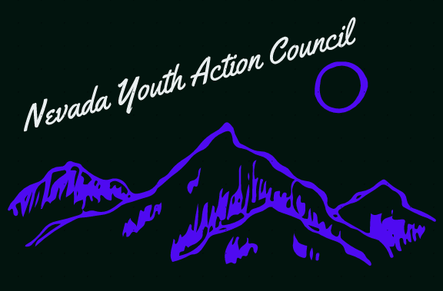

The inhumanity of institutionalization

yet another consequence of innafordable housing
Institutionalization. How can we begin to summarize what this is? A human rights violation. An inhumane and torturous practice. Or “placed in the care of a specialized institution” as defined by the Merriam-Webster dictionary. None of these really capture it. Maybe the definition of Social Breakdown Syndrome, a common consequence of institutionalization, would get us closer to a complete summary? The “deterioration of social and interpersonal skills, work habits, and behavior” as defined by the Miller-Keane Encyclopedia and Dictionary of Medicine, Nursing, and Allied Health, Seventh Edition. This doesn’t quite capture what institutionalization is either. Another way to think about institutionalization is to witness what happens with institutionalized children in the case of deprivation dwarfism. A situation in which children are so emotionally starved and neglected their physical growth is halted, even with adequate nutrition. Not that malnutrition is uncommon with institutionalization either.
However you might describe institutionalization it is technically unconstitutional to institutionalize people “unnecessarily” according to the landmark 1999 Olmstead decision from the United States Supreme Court. Which stated that people with disabilities have a right to the services necessary for them to live and participate within their communities under Title II of the Americans with Disabilities Act (ADA).
Our community here in Nevada has a right to live within the community, not segregated away in an institution. Unfortunately, the State of Nevada often fails to provide the legally necessary community-based services to prevent children with behavioral health disabilities from being segregated into an institution. But Don’t take our word for it. According to a public report released last year from the Federal Department of Justice (DOJ), Nevada violates the ADA with the overreliance on segregated institutions for children with behavioral health disabilities. Institutions that are often placed out of State, hundreds or thousands of miles away from the community. With placements that have lasted years, robbing children of large chunks of their childhood. You can read this terrifying report for yourself here:
https://www.justice.gov/opa/press-release/file/1540616/download
The Nevada Youth Action Council supports people living in their communities and participating in all aspects of community life to the degree that they wish to. If you want support getting involved with advocating for a better status quo for people with disabilities, please reach out to the Youth Leader at CodyButler@adsd.nv.gov
If you are interested in serving on a council by and for youths with disabilities, please visit:

https://www.nvsilc.com/get-involved/join-the-youth-group/

“Was the process of institutionalization both so powerful and subtle, that I could be aware of it and yet be unable to resist?”- Dr. Irving Kenneth Zola

