Nevada Youth Action Council Newsletter
  - March 2023 Edition
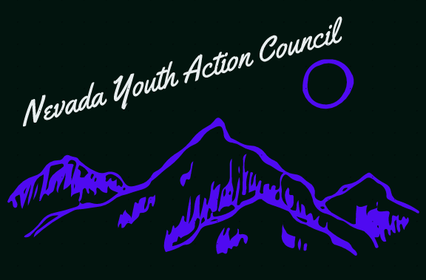

People with disabilities and exploitation

Sheltered workshops and poverty
The Americans with Disabilities Act was passed in 1990. That was 33 years ago as of the writing of this newsletter. As written in the ADA, discrimination against people with disabilities in employment is prohibited. Despite this, discrimination in employment remains rampant nationwide and can be seen in the statistics. According to a 2018 report from Cornell University, the number of working-age people with disabilities that were employed was 37.8%. This does not mean that the jobs paid a living wage, or that the employment was full time. The percentage of working-age people with disabilities that were working full-time/full-year was 24.7%. The poverty rate for working-age people with disabilities was 26%.
This might sound surprising, but it is actually perfectly legal to pay people with disabilities less than the minimum wage. Much less, with wages being reported as low as 3 cents an hour according to a 2013 NBC news investigation. How is this legal? It is legal under Section 14(c) of the hilariously named Fair Labor Standards Act of 1938, legislation from 85 years ago. The Fair Labor Standards Act states that employers that qualify for 14(c) certificates are allowed to pay people with disabilities less than the minimum wage.
Employers with Section 14(c) certificates run what are often called sheltered workshops. These are workplaces that employ people with disabilities and segregates them from their non-disabled peers. Thereby denying them inclusion in their communities. In addition to paying them far less than minimum wage. A 2018 report from the federal National Council on Disability found that the CEO of the biggest sheltered workshop had collected a salary of 1.1 million dollars while simultaneously paying 1,790 employees less than minimum wage. The work that is done at sheltered workshops like these almost always falls into what is called the 8 Fs of disability employment: food, filth, fetching, folding, filing, flower, festive and friendly. This arrangement is supposedly ethical because the experience and connections gained by employees at sheltered workshops are supposed to help them gain a job with actual wages down the road. But this rarely happens in practice, and people find themselves stuck working in sheltered workshops for years.
One of the solutions for attaining good employment often talked about is education. The higher your education level, the better jobs you have access to right? Well going back to that Cornell University report from 2018 mentioned earlier: education is also inaccessible for people with disabilities. The percentage of working age people with disabilities that had a high school diploma or equivalent was 34.2%, while 32% had some college or an associates degree, and only 15.2% had a bachelor’s degree. How long are we going to allow this to be the status quo for people with disabilities?
If this is something you find unacceptable and you would like to get involved in the efforts to change this you have options. There is currently a big push in Nevada for Employment First, a model that prioritizes employment as the first and preferred outcome for people with disabilities. You can learn more details on Employment First from the newsletter from January 2023. You can also check out this Public News Service article here: https://www.publicnewsservice.org/2023-01-19/livable-wages-working-families/nv-group-sounds-alarm-on-integrated-work-for-disabled-community/a82402-1
The Nevada Youth Action Council and the Nevada Statewide Independent Living Council are two organizations among many that are collaborating on Employment First. Please do not hesitate to reach out to the Youth Leader at CodyButler@adsd.nv.gov if you would like assistance with getting your voice out and included in this community effort. Everyone should have a right to meaningful work if they want it.

If you are interested in serving on a council by and for youths with disabilities, please visit:

https://www.nvsilc.com/get-involved/join-the-youth-group/

“The ADA was a wonderful achievement. But it was only the tip of the iceberg. You can pass a law but until you can change society’s attitudes, that law won’t mean much”- Denise Sherer Jacobson

