Nevada Youth Action Council Newsletter
  - Februar 2023 Edition
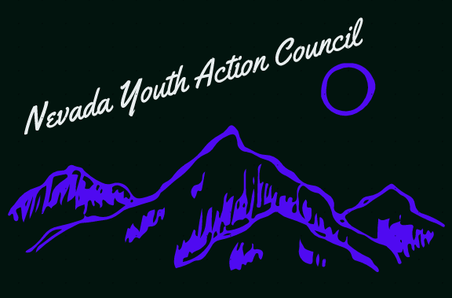

Getting involved with the 82nd (2023) legislative session in Nevada

Subtitle if needed
The next legislative session for the State of Nevada is almost here! It will officially start on Monday February 6th. As members of the public, you have more sway in the legislative process and the passage of State laws than you might realize!
There are many ways to engage, including contacting your State legislators or providing public comment during legislative sessions or hearings. For providing public comment you can do so in person at the legislative building in Carson City or the Grant Sawyer building in Las Vegas, by calling in and providing comment over phone or by submitting written public comment on the Nevada legislature website. You can do more than one of these! One legislative strategy is to provide a summary of your arguments verbally, and then submit more detailed statistics and arguments for written comment. The Nevada legislature website can be found here:
https://www.leg.state.nv.us/
The legislature website has a ton of useful information! It includes the Nevada Electronic Legislative Information System (NELIS): which lists the dates of all sessions and hearings as they are scheduled, lists all Bill Draft Requests (BDRs) and their sponsors, status and budgets. NELIS tracks all of the important deadlines throughout the duration of the legislative session too! The website also has the contact information for all legislators, and you can register an account with the legislature and track up to 10 BDRs or bills for free. This includes automated emails notifying you of major updates and meetings regarding the bills you track!
The legislative session is very overwhelming at first! There is a lot of information to take in. One helpful resource to assist with understanding and navigating the legislature and its website is the blog at Vote Nevada! You can find it here:
https://vote-nevada-blog.org/recorded-advocacy-resources/
Vote Nevada is a nonprofit organization with no national affiliation dedicated to helping Nevadans exercise civil engagement! Their blog contains a variety of useful resources and information including a list of effective legislative strategies and public comment strategies, a tour of the website, a glossary of legislative terminology, strategies for using social media to engage with the legislative process and many more!
Cooperation is key! Don’t try to do everything by yourself. Connect with people that care about the same issues as you and work together to push for the legislative goals you want! If you would like some support or mentoring with how to engage as a young person you can also reach out to the Youth Leader, Cody Butler here: CodyButler@adsd.nv.gov

If you are interested in serving on a council by and for youths with disabilities, please visit:

https://www.nvsilc.com/get-involved/join-the-youth-group/

“Every great dream begins with a dreamer. Always remember, you have within you the strength, the patience, and the passion to reach for the stars to change the world”-Harriet Tubman

