Nevada Youth Action Council Newsletter
  - January 2023 Edition
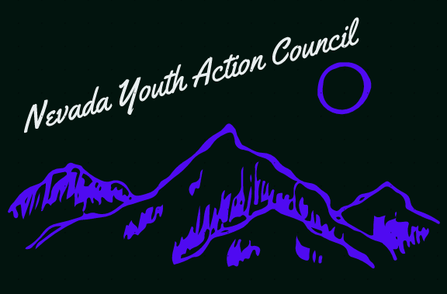

Employment First for Nevada

People with Disabilities deserve decent work and a living wage
Employment First is a model that prioritizes employment as the first and preferred outcome for people with disabilities. Regardless of the level of disability. An Employment First model promotes self-worth and dignity, and it reduces Medicaid and welfare expenditures for the disability community, which will be better utilized elsewhere. All people should be able to participate in employment and community life to the degree that they wish to.
Specifically, Employment First is concerned with Competitive Integrated Employment (CIE). Or employment that offers people with disabilities the same pay, opportunities for advancement, and access to further training and education as afforded to non-disabled peers. Sheltered workshops and other forms of segregated employment are a disservice to us. We belong in the broader community and have many talents as individuals to offer the world. We deserve to be included.
There are 40 States in America that have adopted an employment first model. Colorado is an example of a nearby state using an Employment First model with great success. Colorado is like Nevada in many ways, so we know we can do it here, too.
To learn more about Employment First please check out this map from the Association of People Supporting Employment First (APSE) which provides details on various states and their progress with Employment First goals:
https://apse.org/legislative-advocacy/employment-first/employment-first-map/
If you are interested in serving on a council by and for youths with disabilities, please visit:

https://www.nvsilc.com/get-involved/join-the-youth-group/

“Decent work is at the heart of the search for dignity for the individual, stability for the family and peace in the community” -Juan Somavía

