Nevada Youth Action Council Newsletter
  - November 2022 Edition
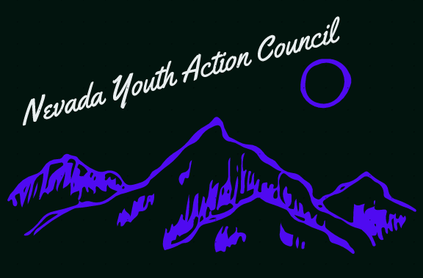

People with disabilities and bullying
Bullying is an old problem. It is a human problem, one that we cannot seem to get rid of. And according to the Centers for Disease Control and Prevention (CDC), the United States Department of Education (ED), and the United States Department of Justice (DOJ): people with disabilities are more likely to experience bullying throughout many stages of life. Including at school and in the workplace. As bullying is often directed at those who are perceived to be different from their peers this makes sense.
Surprisingly, there aren’t any federal laws that directly prohibit bullying. However, there are a group of civil rights laws that prohibit harassment and discrimination on the basis of disability and other characteristics. When viewing bullying through this context, we have a solid legal basis for protecting our right to participate in the community free from bullying. These legal protections for people with disabilities include Titles II and III of the Americans with Disabilities Act (ADA), Section 504 of The Rehabilitation Act of 1973, and the Individuals with Disabilities Education Act (IDEA). Legal protections for intersecting identities, such as race and gender, include Titles IV and VI of the Civil Rights Act of 1964, and Title IX of the Education Amendments of 1972.
Despite these protections bullying continues to persist. Many youths are forced out of their communities and schools, switching to online schooling options to escape the bullying. For people with disabilities, bullying can be especially brutal. People can be forced to inhale or consume substances they are allergic to, thereby putting their life at risk. Assistive technology can be intentionally broken. Isolation and exclusion from the social network can be especially vicious.
Bullying extracts a heavy cost. Victims of bullying face horrific long-term consequences such as: new or worsening depression and anxiety, low self-esteem, loneliness and isolation from peers, physical injuries, symptoms of traumatic stress, worse performance in school and work, loss of income, housing and food insecurity, new or worsening suicidal ideation and an increased possibility of suicide attempts. The commonplace nature of bullying is unacceptable. We as human beings should be better than this. We can be better than this. If we want to be.

If you are interested in serving on a council by and for youths with disabilities, please visit:

https://www.nvsilc.com/get-involved/join-the-youth-group/

“Bullying builds character like nuclear waste creates superheroes. It's a rare occurrence and often does much more damage than endowment.”-Zack W. Van

