Nevada Youth Action Council Newsletter
  - October 2022 Edition
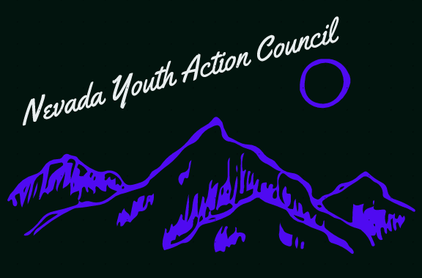

The olmstead decision and the importance of caregiving

In solidarity with Caregivers
In 1999, the disability community scored a huge victory with the Supreme Court ruling in Olmstead v L.C. & E.W, now commonly called the Olmstead Decision. This landmark win for disability justice ruled that people with disabilities have a right to live in their communities and partake in all aspects of community life they choose to with reasonable accommodations. And that “unnecessary” institutionalization of people with disabilities was unconstitutional. One such reasonable accommodation is daily living assistance provided by the likes of caregivers.
Caregiving is difficult and critically important work. Without it, many people with disabilities who would otherwise live a fulfilling and independent life in the community will find themselves institutionalized and unable to control the direction of their own lives. Unfortunately, the field of caregiving is in trouble. Professional caregivers such as Personal Care Assisstants (PCAs) and Certified Nursing Assistants (CNAs) often earn low wages and work unmanageable hours. This contributes to a shortage of needed caregiving services. This void is often filled by important family and friend caregivers, who need and deserve more financial and peer support. Caregiving is one of the biggest forces against institutionalization that we could ask for, and it deserves to be compensated and treated as such.
The Youth Action Council stands in solidarity with our community’s caregivers. Please consider joining our friends at the Nevada Caregivers Coalition and their annual Caregiver Recognition Event on November 10th from 11:30pm-1:30pm PT and showing our caregivers some love! More information here:
https://nvcaregiverscoalition.com/2022-caregiver-recognition-event/
If you are interested in serving on a council by and for youths with disabilities, please visit:

https://www.nvsilc.com/get-involved/join-the-youth-group/

“Too often we underestimate the power of a touch, a smile, a kind word, a listening ear, an honest compliment, or the smallest act of caring, all of which have the potential to turn a life around.”- Leo Buscaglia

