Nevada Youth Action Council Newsletter
  - September 2022 Edition
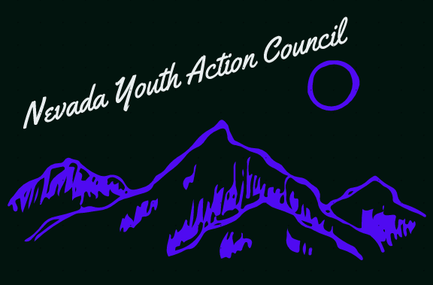

Disability visibility and the disfigured villain trope
Disability visibility has become an increasingly important topic of conversation within the disability community. Part of this conversation revolves around the portrayal of characters with disabilities in popular media and how this representation can affect societal attitudes about people with disabilities. Unfortunately for us, people with disabilities have a long and highly visible history of representation in media: as villains.
This is particularly relevant for people with facial deformities whose representative characters are almost exclusively portrayed as especially evil and heinous. Popular examples of villains with disabilities or deformities include The Joker from the Batman series, Gollum from The Lord of the Rings, Darth Vader and Emperor Palpatine from Star Wars, Lord Voldemort from Harry Potter, Captain Hook from Peter Pan, Scar from the Lion King, Freddy Krueger from the Nightmare on Elm Street, Dr. Poison from the Wonder Woman series, and an excessive number of James Bond antagonists. There are comparatively few examples of characters with disabilities being portrayed in a heroic role.
The Youth Action Council would like to affirm that disability is a normal and natural part of the human condition, and not a signal of moral failing or villainy. This is not to say that people with disabilities should never be portrayed in an antagonistic role as all human beings are capable of acts of cruelty. But this disproportionate representation of us as evil monsters is both revealing of and influential on societal biases about our community. We urge that writers and other creative thinkers consider more diverse ways of including characters with disabilities within their stories.

If you are interested serving on a council by and for youths with disabilities, please visit:

https://www.nvsilc.com/get-involved/join-the-youth-group/

“I am different, not less.” – Dr. Temple Grandin

