Nevada Youth Action Council Newsletter
  - august 2022 Edition
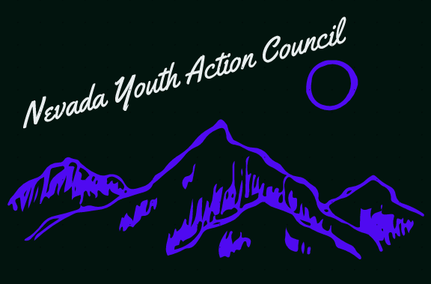

The youth action council is committed to intersectionality
Intersectionality is defined in the Merriam-Webster dictionary as follows: “the complex, cumulative way in which the effects of multiple forms of discrimination (such as racism, sexism, and classism) combine, overlap, or intersect especially in the experiences of marginalized individuals or groups”.
While it is true that the Nevada Youth Action Council serves the disability community, a focus on intersectional thought and decision-making remains of paramount importance. This is because ableism is not the only oppressive force Nevadan youths with disabilities face daily. Other such oppressive forces include but are not limited to: homophobia, transphobia, sexism, racism, classism, xenophobia, ageism and discrimination based on veteran status. A fixation on ableism alone would be a disservice to the disability community and developing an understanding of how ableism relates with other discriminatory structures in our world continues to be vital. Youth Action Council members are not perfect, but we continue to learn and grow together.
If you are interested serving on a council by and for youths with disabilities, please visit:

https://www.nvsilc.com/get-involved/join-the-youth-group/

“Understanding the interconnected nature of oppression will help us realize the interconnected nature of liberation.”- Aditi Mayer

