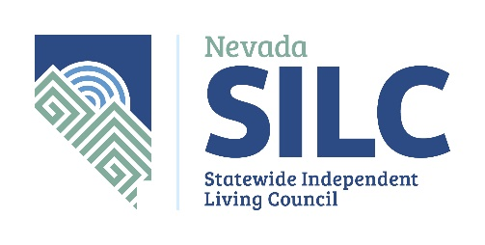
P.O. Box 33386
Las Vegas, NV 89133
nvsilc@adsd.nv.gov
https://www.nvsilc.com/

March 29, 2021
Senator James Settelmeyer
2388 Highway 395
Minden, NV 89423-8923
James.Settelmeyer@sen.state.nv.us

Dear Senator Settelmeyer:

First, we would like to thank you for caring about personal care services for Nevadans who utilize those services to stay in their homes! We noticed that you sponsored Senate Bill 93, which would give Nevadans on Medicaid Home and Community Based Waivers the option to pay caregivers and personal care attendants directly and allow folks to suspend their eligibility while incarcerated. Although this was determined to have a fiscal impact in the next biennium, we understand the cost is much lower than it would be to pay for nursing home care or institutionalization. As you are probably aware, the cost of institutionalization is typically double what it costs to provide home and community based services so folks can stay home.
This is also of importance because of the recent public concern that our State has not done enough to support diversion from institutions in accordance with Olmstead v. L.C., 527 U.S. (1999) during this pandemic, where a disproportionate percentage of COVID-19 deaths have occurred. The Americans with Disabilities Act (ADA) requires that people with disabilities fully interact with nondisabled persons in an integrated setting where possible and that services, programs and activities must adhere to this mandate. The SILC upholds these ideals by practicing the Independent Living Philosophy: All people have the right to control and direct their own lives, leading to self-determination and independence, and people with disabilities also have the right to actively participate in all aspects of community life to any extent they choose. Your bill supports this philosophy, and we are excited and hopeful it will pass in this 81st Legislative Session.

With Gratitude,

The Nevada Statewide Independent Living Council

Primary Contact: Dawn Lyons, Executive Director (702) 757-7990

