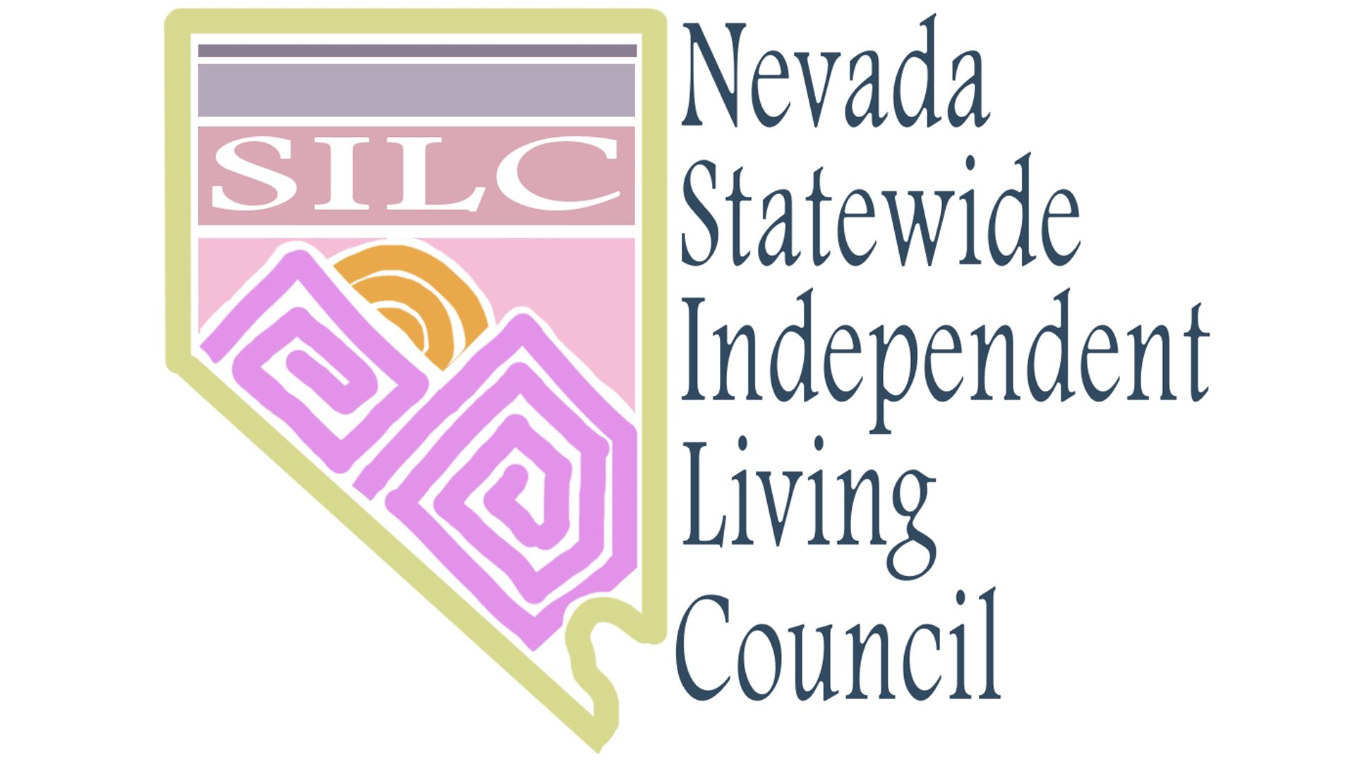

Nevada SILC Policies and Procedures Manual
  - Rev. 11/18/2020

NV SILC  PO Box 33386  Las Vegas, NV 89133 |  | p. (702) 486-5940 |  | nvsilc@adsd.nv.gov  http://adsd.nv.gov/Boards/SILC/SILC/  Website - http://NVSILC.com

Table of Contents
- Policies and Procedures Summary 2
- NV SILC: What We’re About 3
Objective
Mission Statement
Vision Statement

- Purpose of the Nevada SILC 5

- Policies and Procedures 6+
Recruitment
Disputes / Conflicts of Interest
Official Meetings
Accommodations
State Plan for Independent Living (SPIL) Development and Implementation
Eligibility of the Centers for Independent Living (CIL) for SPIL Inclusivity
Code of Ethics and Member Etiquette
Hiring and Evaluation of Executive Director and Staff

Policies and Procedures Summary
The Nevada Statewide Independent Living Council (NV SILC) is an autonomous, federally-mandated board that serves the entire State providing education and support for Independent Living services throughout. It consists of a group of volunteer self-advocates appointed by the Governor and has a majority of individuals with disabilities in order to present a strong consumer voice promoting Independent Living and the Independent Living Philosophy. Individuals with disabilities of all types are represented in the Nevada SILC’s Mission and Vision.

NV SILC – What We’re About

SPIL Goals & Objectives

Goal 1: Improve Access to Independent Living Supports and Services Statewide.

Objective 1A:
Providers of Part B-funded, high-need or new IL services will report an increase in consumers served, as measured each quarter for the fiscal year (October 1st through September 30th, 2021, 2022, and 2023).

Objective 1B:
Increase the CILs’ operating budget through Part B subawards by at least 4% during the October 1, 2022 and October 1, 2023 award periods

Goal 2: Improve Awareness of Independent Living Network and Philosophy Statewide.

Objective 2A:

SILC will increase number of consumers’ IL awareness as measured in our annual consumer survey by September 30, 2023.

Objective 2B:

SILC will increase accessibility for people with disabilities by November 3, 2023.

Objective 2C:

Develop a Statewide youth presence in the IL Network by September 30, 2023.

Objective 2D:

The SILC will use their new website to increase awareness of the IL Philosophy Statewide by September 30, 2023.

Goal 3: Improve the Effectiveness and Efficiency of the Independent Living Network Statewide.

Objective 3A:

SILC will improve our internal processes for SPIL evaluation.

Objective 3B:

A resource development plan will be completed and ready to be implemented by October 1, 2023.

Objective 3C:

The DSE will increase staff support time to 1.25 FTE that is fully selected, supervised and evaluated by the SILC by September 30, 2023.

Mission Statement
The mission of the Council is to advocate for the development of a network of programs, services and options designed to empower Nevadans with disabilities to live independently in the community.

Vision Statement
The Nevada SILC collaborates to create a community that values respect, equality and self-direction throughout the State.

Purpose of the Nevada SILC
The specific purposes of the Council is:
1. to promote the philosophy of independent living, including a philosophy of consumer control, peer support, self-help, self-determination, equal access and individual and system advocacy in order to maximize the leadership, empowerment, independence, and productivity of individuals with disabilities, and the integration and full inclusion of individuals with disabilities into the mainstream of society;
2. to promote the development and expansion of independent living programs and concepts on a statewide basis;
3. to provide guidance to State agencies and local planning and administrative entities assisted pursuant to Title VII of the Act;
4. to provide guidance to State agencies and local planning and administrative entities that are providing independent living services; and
5. to improve working relationships among councils, centers for independent living, State, federal and non-federal programs.

Policies and Procedures

Recruitment
Procedure:
Each potential new member will be assigned to a designated mentor as soon as the Council is aware of their interest.
Each of the following will be available to the prospective new member in hard copy, online or in the accessible format needed:
1. SILC Fact Sheet
2. NV SILC website’s listed mandatory trainings
3. Membership Checklist of requirements
4. IL vs. Medical model sheet
5. CIL information
6. NV SILC Code of Ethics, Bylaws and Policy and Procedure Manual
Ideally, each potential new member will attend NV SILC and/or NV SILC Subcommittee Meetings prior to appointment.
After working closely with the mentor, the mentor will present a recommendation for membership appointment to the Executive Team, if applicable.
Once the Executive Team agrees, there will be an opportunity for a formal introduction at the next planned Council meeting.
Final Approval of endorsement for membership will be decided at either that meeting or the next SILC Meeting, and endorsement will be provided to the Governor’s Office, along with information to the interested party about where to find the Governor application.

Policy:
The applicant, if possible, will notify the Chairperson within 10 business days of submission to the Governor’s Office.
The Executive Team will review potential memberships within 2 weeks from receiving notice by the mentor.
The Council shall vote to approve endorsement of membership for only those individuals who meet the required Federal Membership Composition Guidelines for the Council per Article V in the NV SILC Bylaws and agree to the NV SILC Code of Ethics.

Disputes / Conflict of Interest
Regarding any potential conflict of interest:
All Council Members shall abstain from conduct that would be deemed as a conflict of interest as outlined in the Nevada SILC bylaws, as well as any consequences arising from occurrences.
Disputes:
Regarding Removal of Council Members:
If any member has two or more unexcused absences within a year from a pre-scheduled meeting, that person will be notified that their membership will be terminated after one more unexcused absence within the following year, and the recommendation for removal as a Council member will be forwarded to the Governor’s Office once the Council has determined the absences are, indeed, unexcused.
An Executive Team consisting of at least two of the following will be established: the Chair, Vice Chair, Executive Director and/or DSE Chief. This Executive Team will have the authority to act on behalf of the SILC in administrative matters. Examples of such administrative matters include, but are not necessarily limited to budget allocations, outside and internal complaints, time-sensitive communication and correspondence, and any other NV SILC matter that requires an immediate or urgent response. Any Executive Team action(s) that may impact the full Council will be reviewed at the next scheduled NV SILC meeting, and no action may be executed without at least two members of the Executive Team’s prior approval.
If any violation of the code of ethics occurs, the Executive Team of the Council will hold a private meeting to determine the severity of the offense. They may or may not be in the following succession:
Mild or 1st Offense – An Executive Team member will inform the individual of their offense in writing (this may be e-mail format), and documentation will be held for a period of one year.
Moderate or 2nd Offense – An Executive Team member will inform the individual of their noted offense in writing (this may be e-mail format), and documentation will be held for a period of one year. If another offense has been documented within one year prior, the first offense documentation will be re-held for another period of one year to start in succession with the second offense documentation. The individual receiving the second offense will be informed it is his/her second offense in a year.
Severe or 3rd Offense – An Executive Team member will communicate to the individual the terms of their suggested consequence, possibly including membership termination and/or a full NV SILC closed session to determine the severity of the offense and resulting consequence(s) and in accordance with any contracts held by the offender with the Nevada SILC or the DSE. Each circumstance will require a unique set of considerations based on all factors; thus, the consequence(s) may vary. The Executive Team has the authority to make any final decision(s).

Resignation of Council Members:
In the event a Council member wishes to resign, the individual shall submit a letter of resignation to the Chair, Executive DIrector and the DSE Representative along with the preferred effective date and a brief description of the reason for resignation. If no date is provided, resignation will be assumed effective upon receipt.

Official Meetings
All official Council and Committee Meetings will be planned, posted, and held according to Nevada Open Meeting Law requirements.
The SILC shall meet at least quarterly according to Federal guidelines (45 CFR 1329.15(a)(3)).

Accommodations
The Nevada SILC is pleased to make reasonable accommodations for any individual who has a disability(s) and wishes to attend a meeting. If special arrangements for the meeting are necessary, please notify the Aging and Disability representative listed on the http://adsd.nv.gov/Boards/SILC/SILC/ website as soon as possible and at least ten business days in advance of the meeting. If you wish, you may e-mail the NV SILC at NVSILC@adsd.nv.gov. Supporting materials for meetings are available at: 3416 Goni Road, #D-132, Carson City, NV 89706 or by contacting the above as referenced.

State Plan for Independent Living (SPIL) Development and Implementation
Town Hall Meetings will be arranged according to Nevada Open Meeting Law at least 6 months in advance of SPIL planning; at least one month prior to submitting the SPIL for approval to the ACL; and at other times as deemed necessary by the SILC or SPIL Workgroup to provide an accurate representation of public needs.
The Nevada SILC will continuously work to improve the process for developing the SPIL.
The Nevada SILC will monitor, review, and evaluate the current SPIL Objectives at least quarterly.

Eligibility of Centers for Independent Living (CIL) for SPIL Inclusivity
According to 45 CFR 1329.17(d)(2)(iii), not less than 51% of CIL’s will participate in the development and approval of the SPIL. All participating CIL’s must be willing to share proof of their Part C approval, upon request by the SILC.

Code of Ethics and Meeting Etiquette
All new members will agree to a Code of Ethics form that states the following:
Nevada Statewide Independent Living Council
Code of Ethics
1. I will uphold and enforce all laws, rules and regulations that apply to
recipients of federal funds and to the SILC.

2. I will make decisions that assure the equal access and independent
living of people with disabilities and will seek to develop, support and maintain
Independent Living Services.

3. I understand that the role of the board is policy making, planning, and
appraisal, and I will help to frame policies and plans only after the
Council has consulted those who will be affected by them.

4. I will carry out my responsibility, not to interfere with the day to day
operations of the Center and/or SILC, but, together with my fellow
Council members, to only hire qualified staff, if applicable.

5. I recognize that authority rests with the Council as a whole, and will
make no individual promises nor take any private action that may compromise
the Council.

6. I refuse to surrender my independent judgment to special interest or
partisan political groups or to use the Council position for personal
gain or for the gain of friends or family.

7. In all activities and decisions of this Council, I will act in respect for
all people, and will assure that the rights and dignity of others are
upheld. I will not bully, threaten or intimidate any other Council member or
stakeholder either during a meeting or outside of meetings.

8. I will refer all complaints to the Executive Team of the SILC and will
act on the complaints from the public only after failure of an
administrative solution.

Signature: __________________________ Date: _________________
Printed Name: ___________________________________

Evaluation of Staff
In the event a new Executive Director must be hired under State employment, the Council Chair, Vice Chair, and DSE Representative will be members of the interview panel and will make the final determination regarding who will be hired for the position. In the event the Chair or Vice Chair is unavailable to participate in the hiring process, another Council member may serve on their behalf.
Each year, during the month of February, the Executive Director (ED) will be evaluated according to established work performance standards (WPS) that have been agreed upon by the Executive Team and DSE Chief. These signatures shall be in effect for as long as the work performance standards do not change for the ED. If any changes are made at any time, new signatures will be documented to establish agreement with all work performance standards/expectations.
The ED may not be evaluated unless designated parties are all in agreement with established WPS. The evaluation will include reasonable goals to ensure growth and improvement according to the established job elements in the WPS. This written evaluation will be kept confidential from all other parties, including the public, and maintained by the DSE in a personnel file designated to the person named as Executive Director. This may be made available to the current Chair and/or Chairperson of the NV SILC, and/or the DSE representative as requested, but will not be shared with any other parties at any time. By accepting the authoritative positions named in this process, you agree to these terms for purposes of confidentiality. The only other person who may access these records is the named person on file serving in the role as Executive Director.

