Executive Order 2017-12
ORDER ESTABLISHING THE STATE INDEPENDENT LIVING COUNCIL AND SUPERSEDING PREVIOUS EXECUTIVE ORDERS
Title VII, Section 705 of the Rehabilitation Act of 1973, as amended, 29 U.S.C. §§ 796-796d-1 (the Act), provides for the establishment of a Statewide Independent Living Council (the Council) consistent with the requirements of the Act; and
WHEREAS, the Council coordinates with the Nevada Aging and Disability Services Division, Disability Services Unit, as the designated state entity (DSE) for independent living services, to promote a philosophy of independent living and empower individuals with disabilities to maximize leadership, economic self-sufficiency, independence, inclusion, and integration into society; and
WHEREAS, the Council and the DSE coordinate with Aging and Disability Services Division, Disability Services Unit, for the provision of independent living services;
NOW, THEREFORE, I, Brian Sandoval, Governor of the State of Nevada, by the authority vested in me by the Constitution and laws of the State of Nevada, and to ensure compliance with the Rehabilitation Act of 1973, as amended, thereby improving the lives of Nevadans with disabilities and independent living service systems, order as follows:
- The Statewide Independent Living Council for the State of Nevada is established.

- The Governor, in accordance with the provisions of the Act, shall make appointments to the Council.
Members of the Council shall be appointed by the Governor and shall serve at the pleasure of the Governor. To achieve a balanced membership on the Council, appointments shall be made with consideration given to geographic representation, gender, and ethnic and cultural diversity.
The Council must include:
- At least one director of a Center for Independent Living chosen by the directors of centers within the State;

- As ex-officio, non-voting members, a representative from the DSE and representatives from other State agencies that provide services for individuals with disabilities.
The remaining Council members may include:
- other representatives from centers for independent living;
- parents and guardians of individuals with disabilities;
- advocates of and for individuals with disabilities;
- representatives from private businesses;
- representatives from organizations that provide services for individuals with disabilities; and
- other appropriate individuals.
A majority of the Council and voting members must be individuals with disabilities, as defined in 34 C.F.R. § 364.4(b), and not employed by any state agency or center for independent living.

The Council shall vote to appoint a Chairperson and Vice-Chairperson among a slate of officers brought forth by the Nominating Committee.
The Council may be incorporated as a private, nonprofit entity in the State of Nevada, but shall not be an entity within a state agency.
Each member shall serve for a term of three years, and no member of the Council may serve more than two consecutive full terms. A member appointed to fill a vacancy occurring prior to the expiration of a term for which a predecessor was appointed shall be appointed for the remainder of such term.
State agencies whose responsibilities impact independent living services to people with disabilities shall cooperate with the DSE and the Council in complying with the Act; other councils, including the State Rehabilitation Council, shall coordinate with the DSE and the Council; the Council shall continue to progress toward autonomy.
The Council's responsibilities are set forth under the Act and shall include the following:
1. Jointly develop and sign the State Plan in conjunction with the DSE; submit the State Plan to the Administration for Community Living, United States Department of Health and Human Services (ACL);

Monitor, review and evaluate the implementation of the State Plan;

- Submit to the ACL such periodic reports as reasonably requested, and keep such records and afford access to such records as the ACL finds necessary to verify such reports;

- Prepare, in conjunction with the DSE, a plan for the provision of such resources; including such staff and personnel as may be necessary and sufficient to carry out the functions of the Council;

Supervise and evaluate such staff and other personnel, consistent with State law, as may be necessary to carry out the functions of the Council; and

6. Ensure that all regularly scheduled meetings of the Council are open to the public and sufficient advance notice is provided.

This order supersedes any previous executive order establishing a State Independent Living Counsel pursuant to the Rehabilitation Act of 1973.

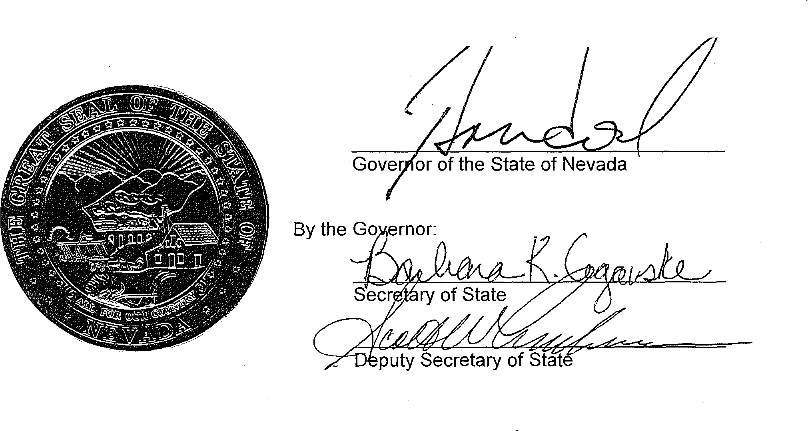
IN WITNESS WHEREOF, I have hereunto set my hand and caused the Great Seal of Nevada to be affixed at the State Capitol
in Carson City this 5th day of September, in the year two thousand and Seventeen.

